***Part 2a: Analytics Dashboard results (5%)***

Between Feb. 15th to Feb. 23rd, eatnomz.com received on average 100 daily visits from Ashburn,VA. The average session length of all those views is less than 1 millisecond - a pattern that most resembles that of automatic web-crawling softwares. Therefore, to maintain the integrity of our results, our overview dashboard only covers traffic from New York, the location that over 90% of Nomz’s customers visit from.

Furthermore, because we have released our Amazon Mechanical Turk Survey on Feb 23rd, we will only analyze Google Analytics data before that date to avoid customer behavior change as a result of the release of the survey.

Between Jan 1 and Feb 23, eatnomz.com overall received 412 sessions from 241 unique New York visitors. Those visitors on average visited 3.91 pages per visit, spent on average 3:23 minutes during those visits, and had a 42.48% bounce rate. 66.95% of the traffic came from desktop, 30.76% come from mobile, and 2.29% come from tablet. Those customers generated $2682.73 of revenue with a conversion rate of 8.87%. The average order value is $43.27.

See Appendix E for screenshots of the standard report

***Part 2b: Web Metrics Custom Reports (20%)***

See Appendix F for reports screenshots.

These reports are for the date range of Jan 1 - Feb 23, and have filtered to include only traffic from the Metro = New York NY location.

Custom metrics that we have included in our reports:

Number of session per user

Revenue per user

Total revenue

E-Commerce conversion rate (where applicable)

The information currently presented in the custom reports indicated that users who make a purchase significantly engage more with the website (higher number of session per user). Furthermore, most who purchase from the website are of the 25-34 age range. Additionally, across device categories, Tablet sessions account for the highest E-Commerce conversion rate and the highest pages per session.

*Note: Site Section Report is not relevant to the eatnomz.com website and therefore we did not create a custom report for it

***Part 2c: Conversion Funnels and Custom Event Tracking (15%)***

We are tracking many conversion related goals using destination URL goals and custom event goals. The following are the destination URL goals:

1. Shopping cart with funnel (Home page > Products page > Specific product page > cart)
2. Shopping cart from homepage (Home page > cart)

Please refer to Appendix G for exhibits relating to our conversion funnels and their configurations.

We are tracking the following custom event goals:

|  |  |  |
| --- | --- | --- |
| **Goal Name (in GA)** | **Location of element** | **Place the following code within the code of your link:** |
| Click Checkout Button | http://www.eatnomz.com/cart | onClick="ga('send', 'event', { eventCategory: 'Checkout Button', eventAction: 'Click', eventLabel: 'Product Tracking', eventValue: 1});" |
| Complete Subscription Button | http://www.eatnomz.com/collections/all/products/chinese-chicken-soup-xiang-gu-ji-tang | onClick="ga('send', 'event', { eventCategory: 'Complete Subscription Button', eventAction: 'Click', eventLabel: 'Subscription Tracking', eventValue: 1});" |
| Click Sign In Button | http://www.eatnomz.com/account/login?sid=476f47400ba608ac6bb99ab9a30dd6d2 | onClick="ga('send', 'event', { eventCategory: 'Sign In Button', eventAction: 'Click', eventLabel: 'User Tracking', eventValue: 1});" |
| Click Sign Up Button | http://www.eatnomz.com/account/register | onClick="ga('send', 'event', { eventCategory: 'Sign Up Button', eventAction: 'Click', eventLabel: 'User Tracking', eventValue: 1});" |

As the website is built on the Shopify platform, many of the key destinations such as the checkout page actually bring the users off the website and to the Shopify domain. As such, we have to track the above custom events. For example, we are using the “checkout button” custom event to distinguish the people who exit the checkout page to complete the transaction (going to the Shopify page) vs those who are exiting the site and not completing a purchase.

*Note: We are in the process of convincing the client to allow us to include these codes into the website’s script and are still trying to navigate the Shopify platform to find the relevant location to paste the code for the “Complete Subscription Button” goal. As such we are unable to provide screenshots in Appendix G to demonstrate that these custom event goals are being tracked correctly.

On top of the goals that we have manually set up through Google Analytics, we are tracking several other goals using the ***E-Commerce*** capabilities made available by linking our Shopify account to google analytics. We are tracking the following using the E-Commerce section:

* Revenue over time
* E-Commerce conversion rates
* Number of transactions over time
* Average order value

We are also tracking shopping and checkout behaviors using the E-Commerce funnels. We used this built in feature as a substitute for assigning values (such as revenue per order) to our custom events. However, if we did not have this set of features, we would have taken the average order value ($36.41) and used it as the value for our “checkout button” custom event. (This would assume that all users who click this button successfully complete the transaction.)

Shopping Behavior:

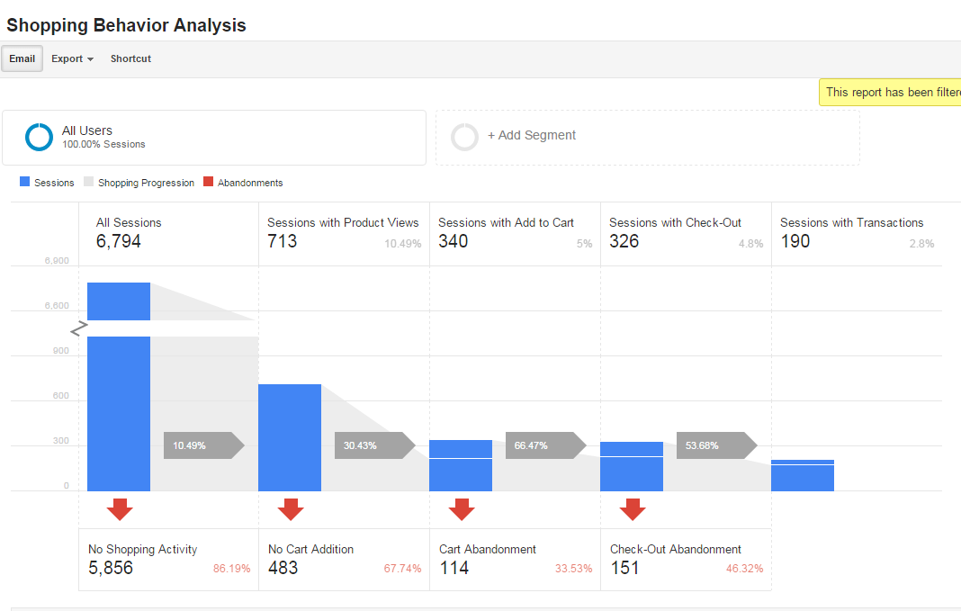

Checkout Behavior:

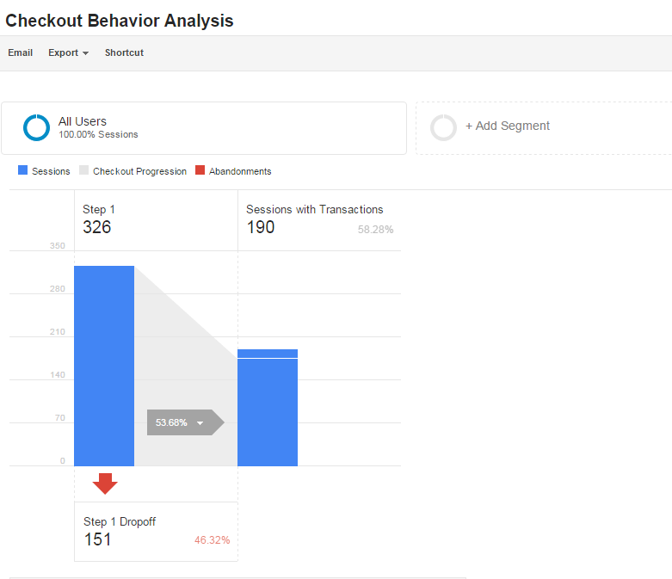

Additionally, we are using Shopify to track our sales, as well as get more granular detail on how our conversion rate from an item in the cart to an item actually purchased is doing. For example, we are using Shopify to get more granular data than is available on Google Analytics, on daily conversion rates for actual purchases and additions to the shopping cart.

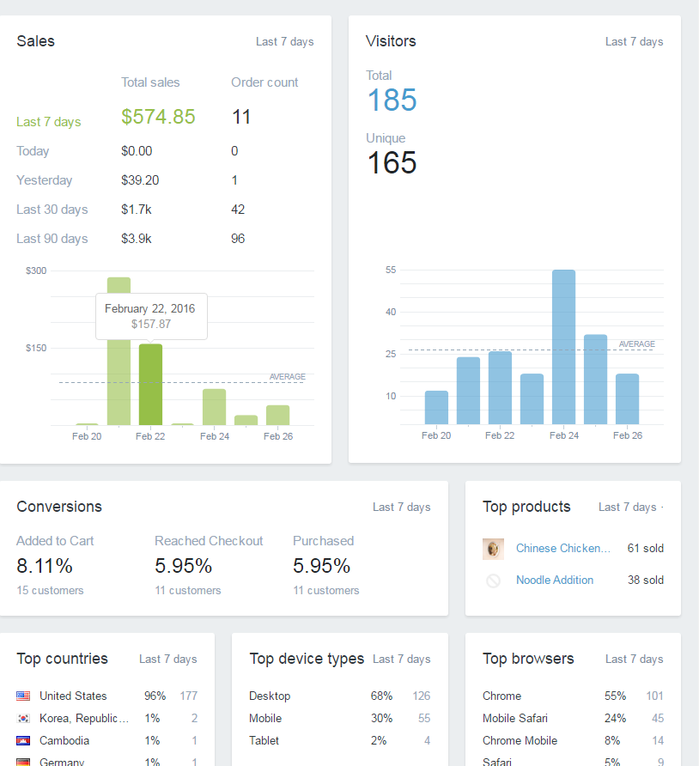

Lastly, we are periodically checking transactional data and tracking which zipcodes order volume is highest. The zipcodes where order volumes are highest is a good indication of where our customers are.

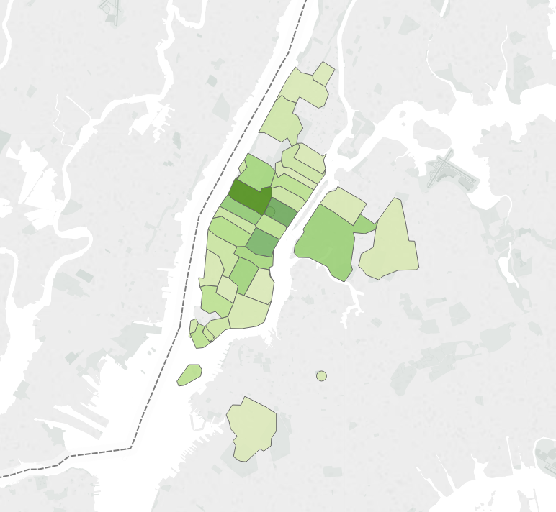

***Part 2d: A/B Testing (15%)***

After reviewing the preliminary survey results and our DUX analysis and recommendations, we decided that we want to change the layout of the homepage. The preliminary results agree with our analysis that the homepage is visually appealing, but contains too much content. They both also agree that the information design of the website could be improved, especially with regard to the readability of product information and accessibility of the product customer reviews.

As such we will introduce a new design for the homepage where fewer content is presented but other information would be more accessible. We will conduct an A/B test where we test the new homepage design against the original design to see if the bounce rate of the website from the homepage would decrease.

Furthermore, conducting our A/B test on the homepage would also be the most feasible for the eatnomz.com website given that does not have a very high traffic.

The A/B test involves testing the current homepage against a new variation of the homepage. The new variation will replace the long detailed description of each product at the bottom of the homepage with pictures, titles, and overall ratings of each product along with an “Add to Cart” and a “Learn More” button. We will test measure the performance of the two pages by the bounce rate

Percentage of population being tested: 50%/ 50%

Test Criterion: Bounce rate on home page/ Time on page/ Exit rate/ Conversion?

Current status of the test: In progress of implementing it

**Appendix E:**

Overview standard report

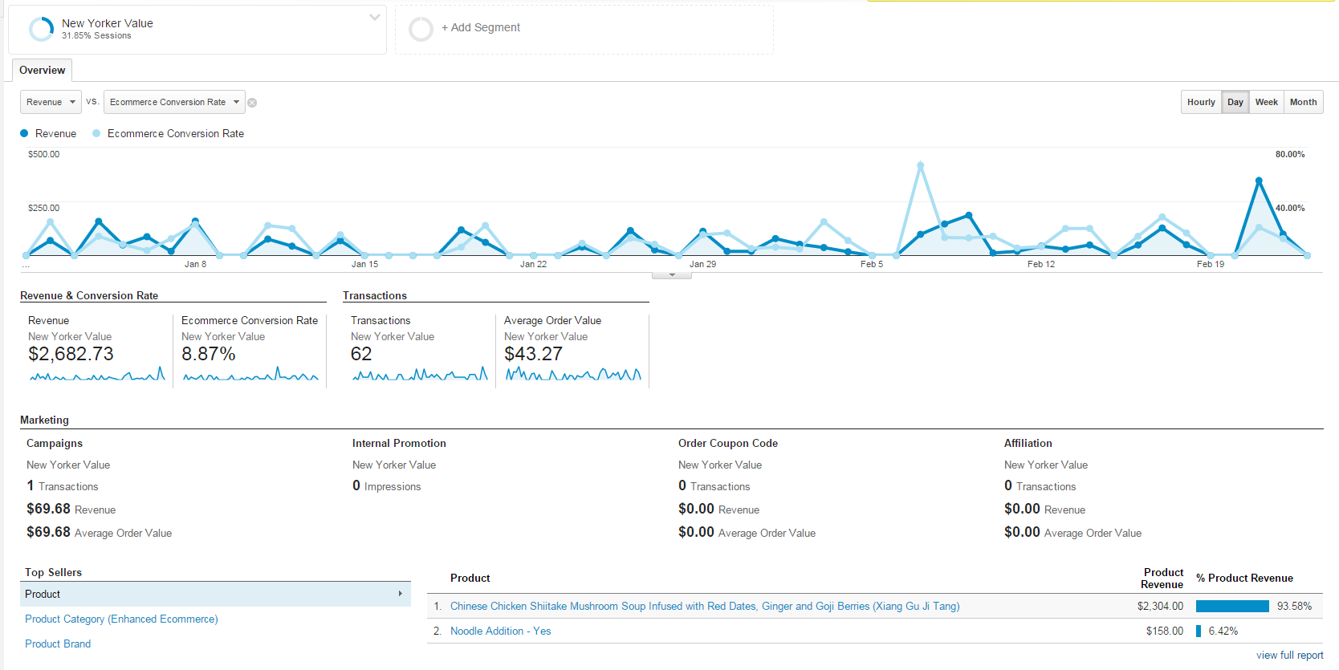

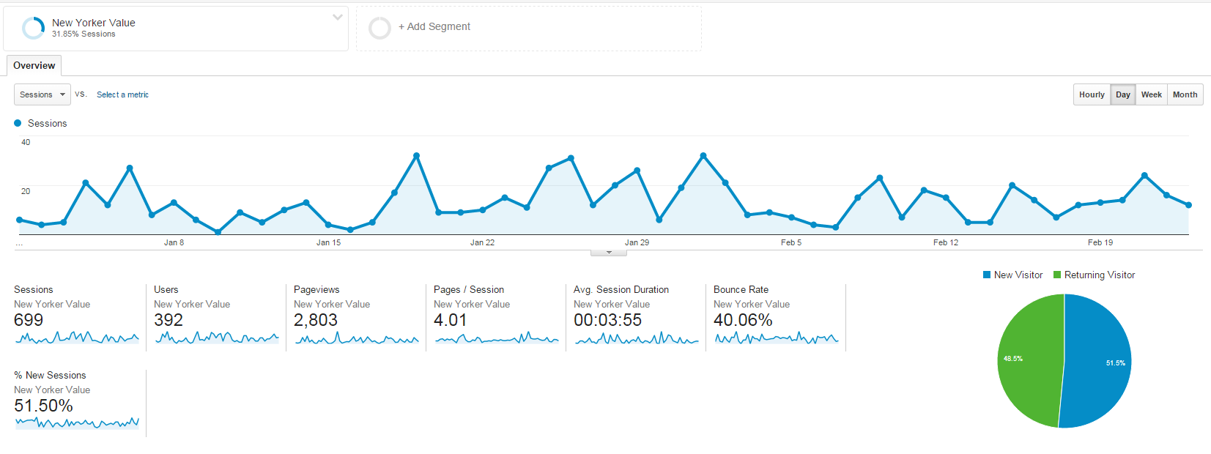

**Appendix F:**

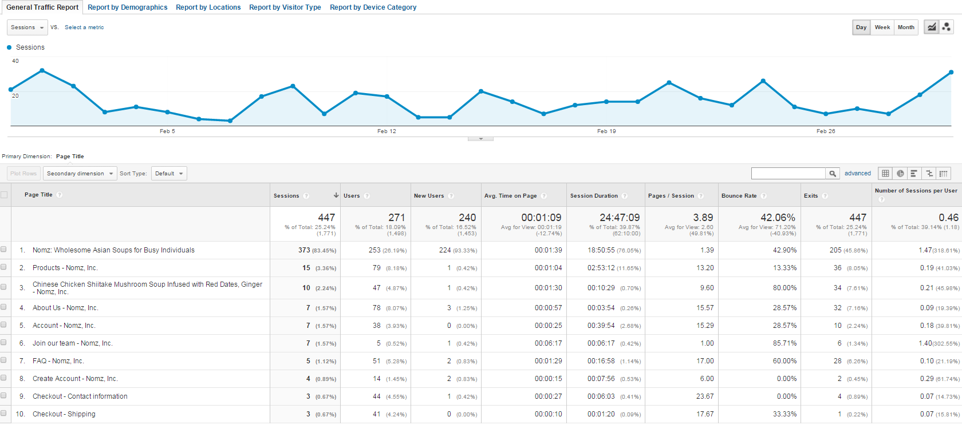General Traffic Report

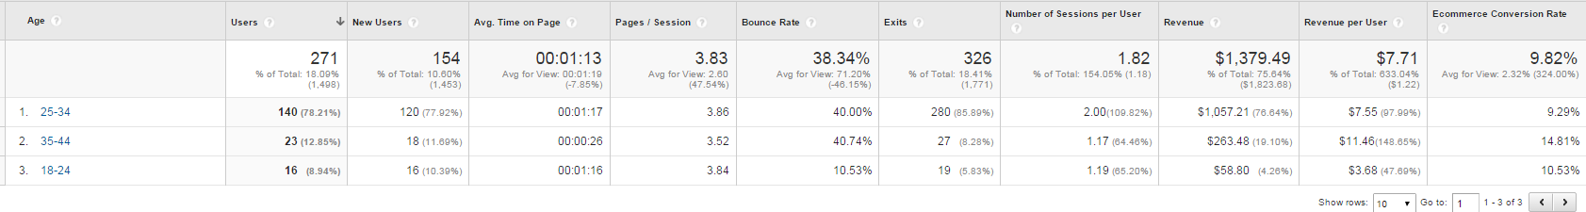Segment specific report – report by demographics

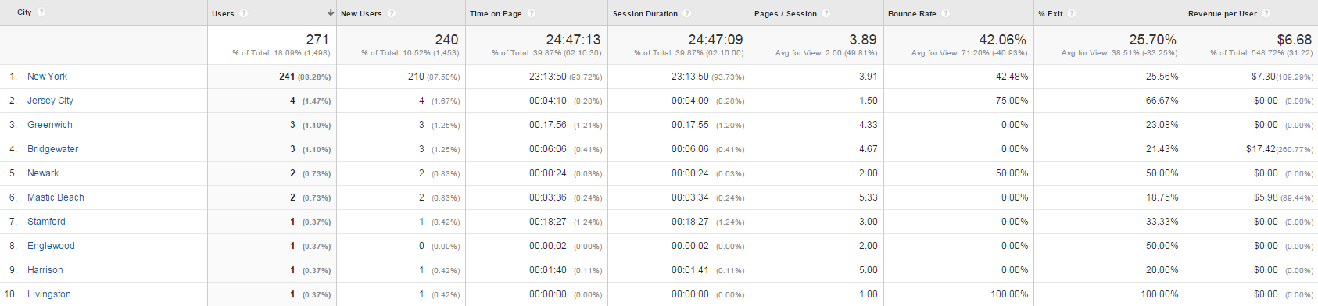Segment specific report – report by locations

Segment specific report – report by visitor type

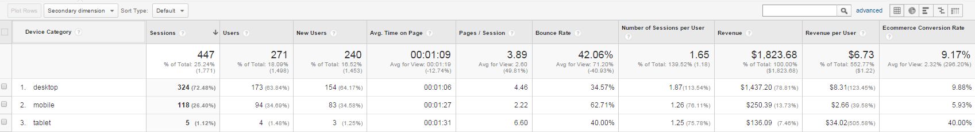Segment specific report – report by device category

**Appendix G:**

Goal Funnels and Configurations

Destination – Shopping cart with funnel

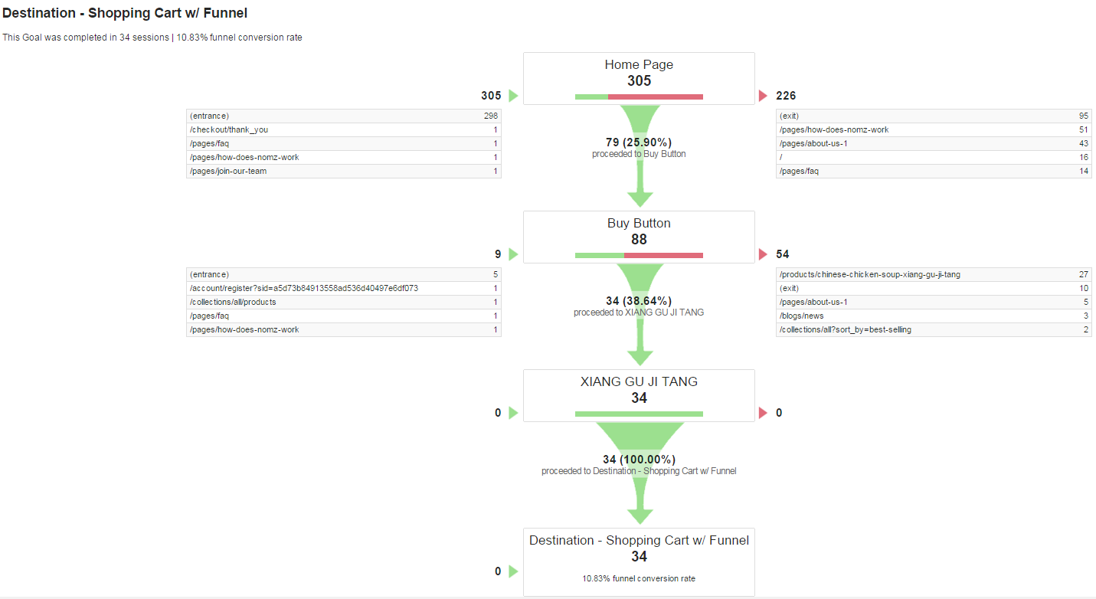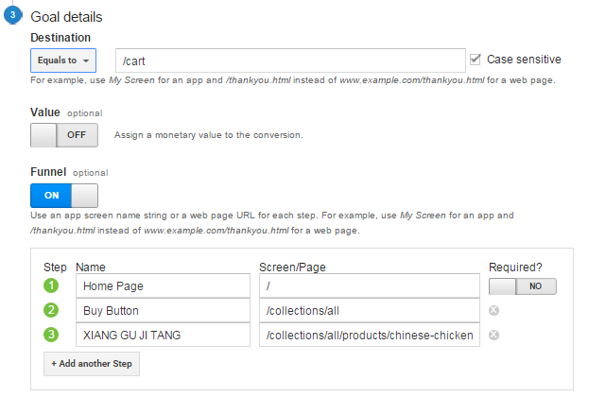

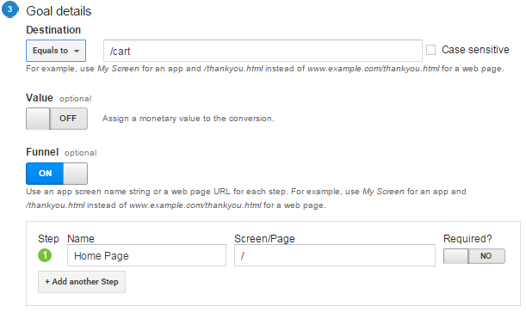Destination – Shopping cart from homepage

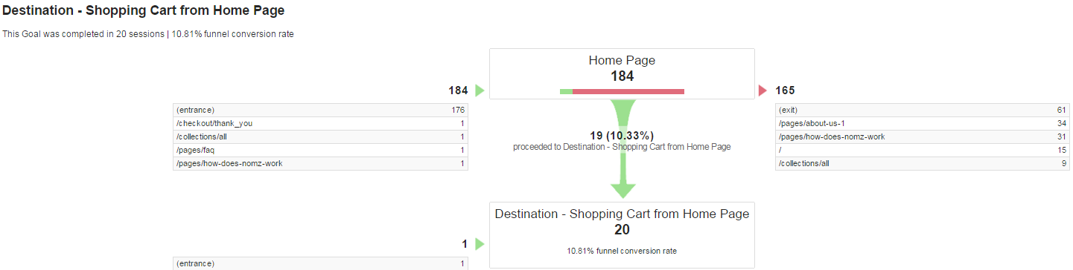

**Appendix H:**

**Homepage A - Original**

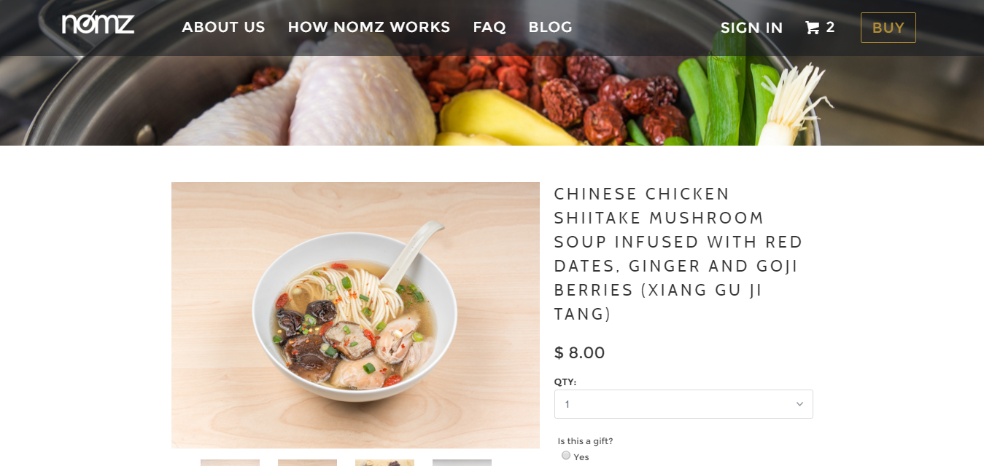

**Homepage B - Variation 1**

